**Development History**

**for**

**STU_ALERT_001**

**Overview of the project** **3**

**Phase 1** **3**

Milestones 3

Current Status 3

**Phase 2** **5**

Milestones 5

Current Status 6

**Phase 3** **8**

Milestones 8

Current Status 8

# Overview of the project

The Student Alert is a desktop application that is intended to provide a platform that makes it easy for children to prioritize their schedule and alerts them when they should be working on assignments. It allows them to enter their availability and assignment details and it builds a schedule for them to follow in order to complete their assignments by the due date.

# Phase 1

Date Completed: 04/19/2020

## Milestones

Currently we have accomplished as we planned. We have completed the project plan, test case, user guide, software design specification and GUI design.

## Current Status

We are currently almost finished with the dashboard to include all the features and the file system. We are ready to work on the add, delete, and edit assignment screens, finish the login/out page, load from file, save from file, and overdue assignments. Some of the pages are:

The main and login page

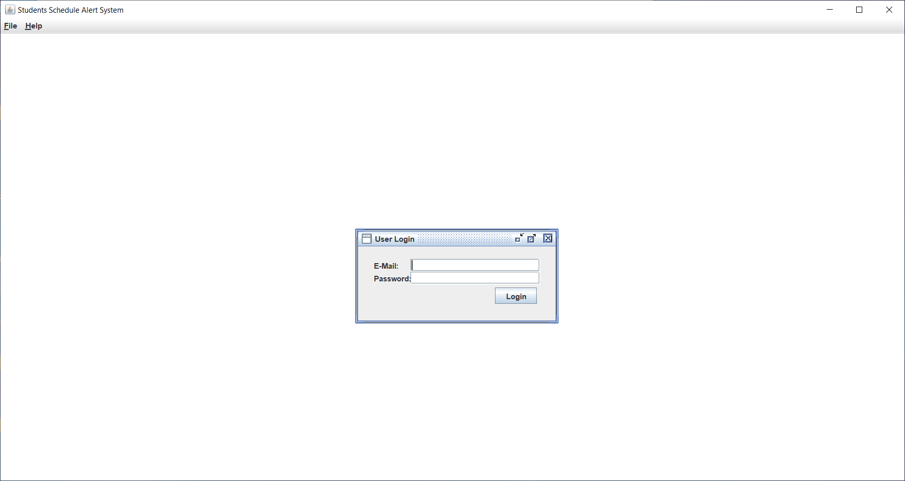

Inside page

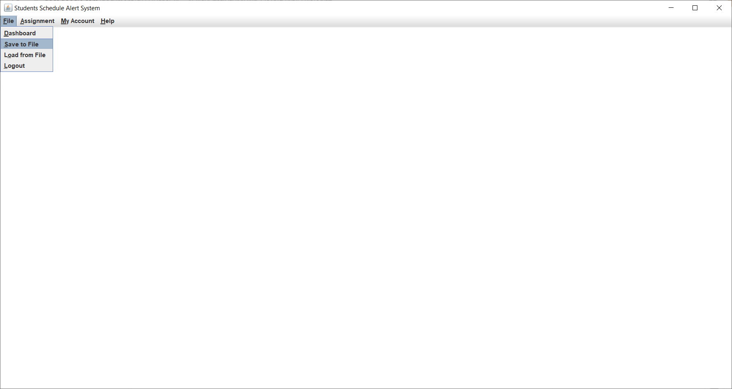

Dashboard

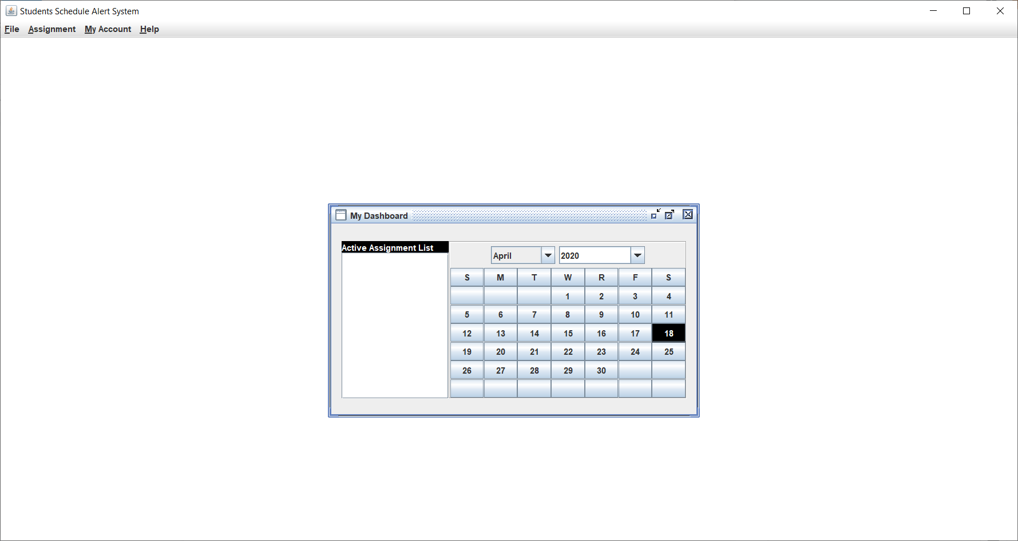

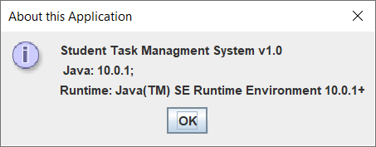

# Phase 2

Date Completed: 04/27/2020

## Milestones

We have completed the project plan, test case, user guide, software design specification and GUI design. Last week, we had developed the GUI skeleton. This week we built upon that by adding methods for each of the components and tweaking the GUI design to fit the software needs.

## Current Status

This week we added the Availability > Edit Availability menu option to the GUI. (See Figure 1) We have also developed the file structure for the data files and began integrating the data into the components. (See Figure 2) We incorporated the ability to generate unique user id and assignment ids to store in the files. We added the function for creating the default user files when a user is registered. Additionally, we modified the Assignment screen slightly to remove the use of specific start and end dates as the schedule function will assign those instead of the user. (See Figure 3)

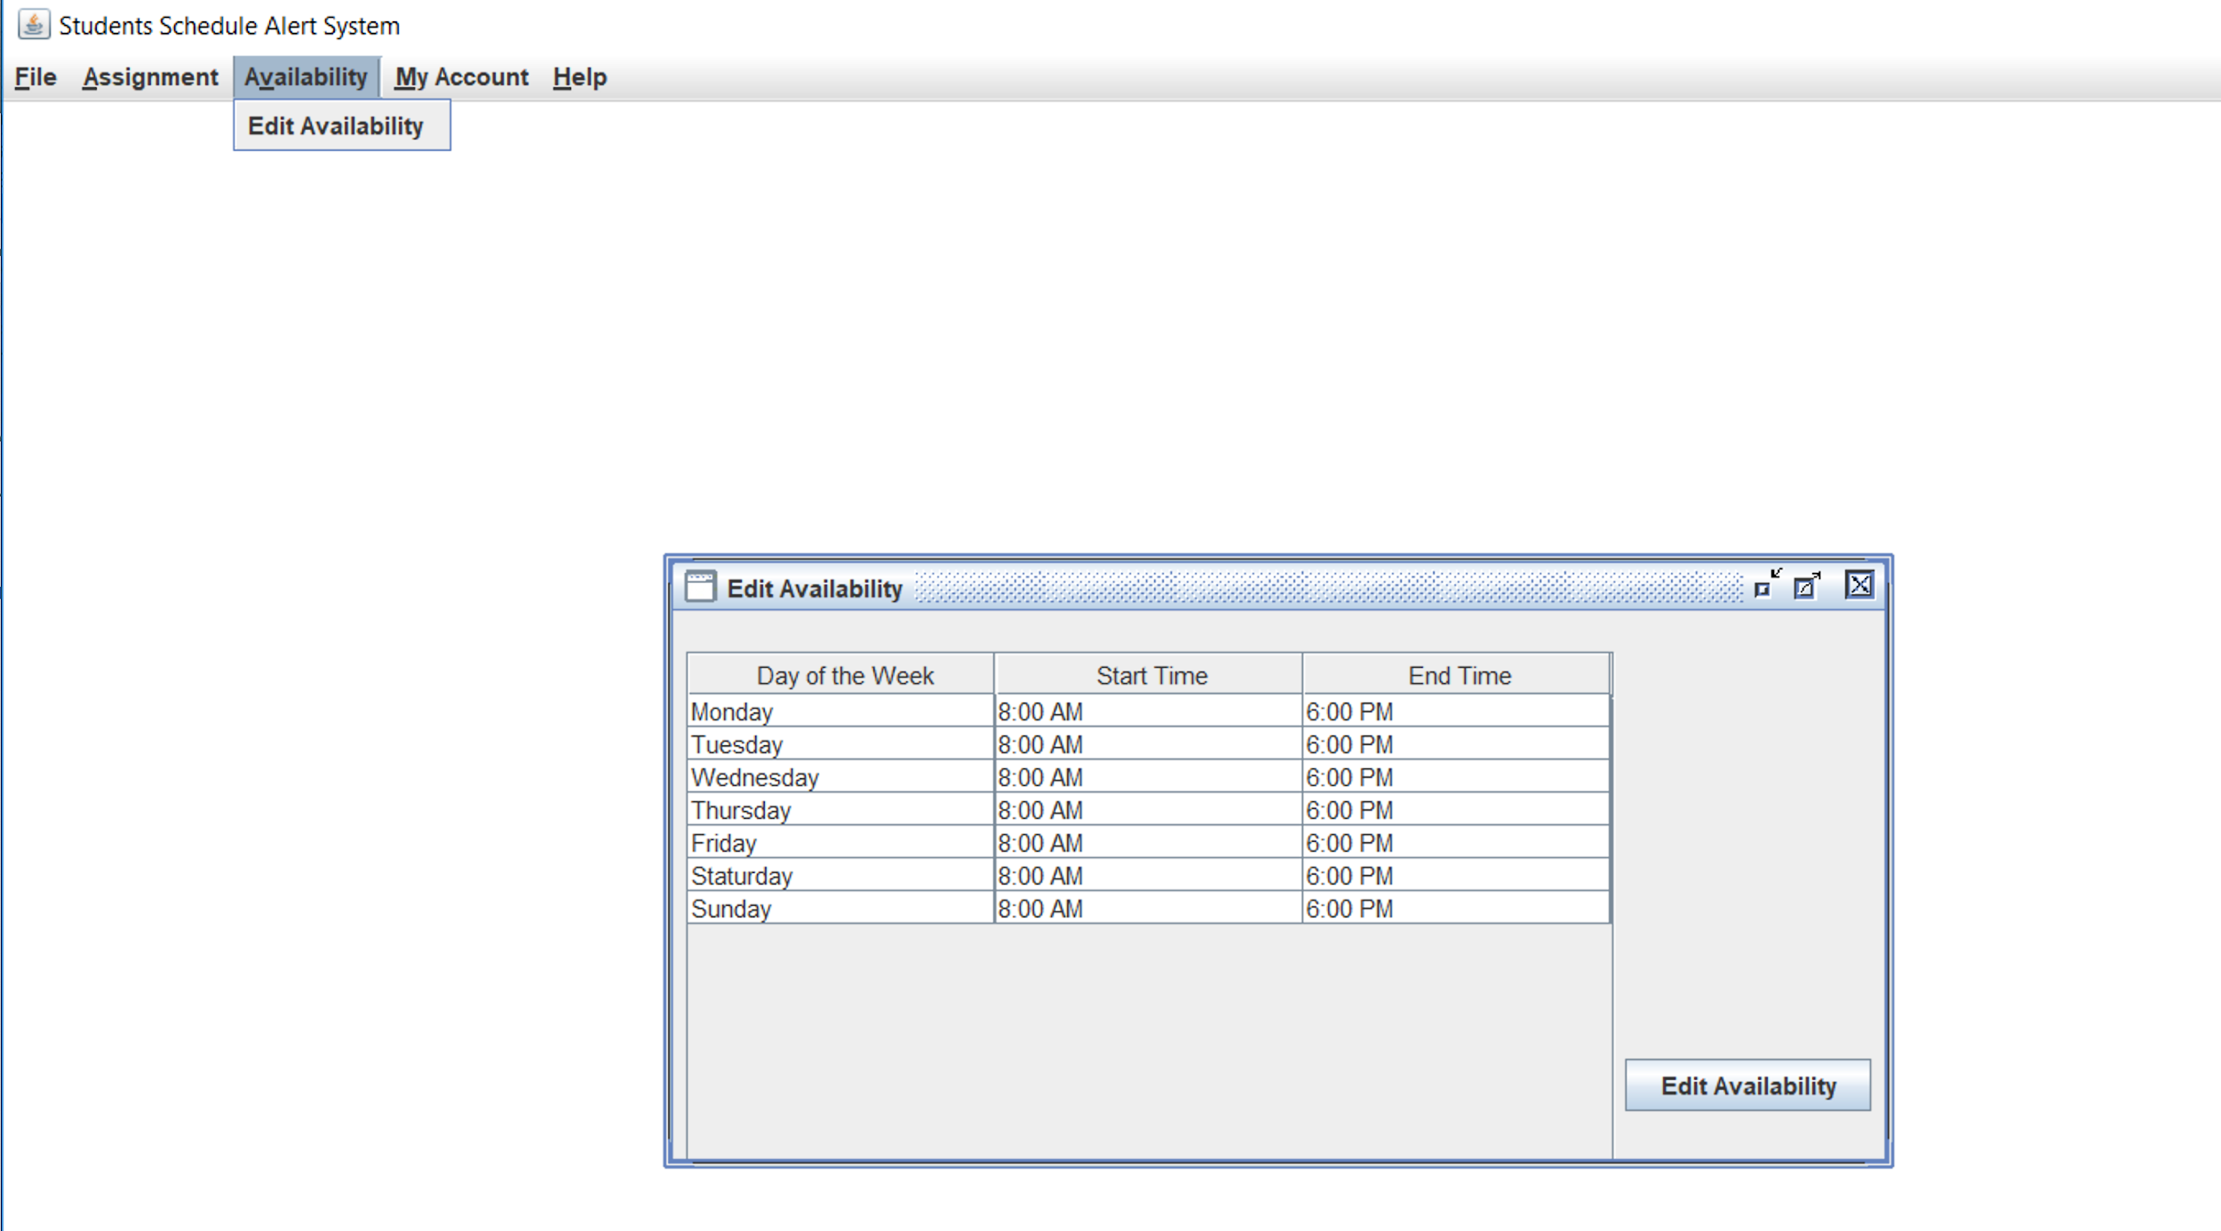

Figure 1: Edit Availability Screen

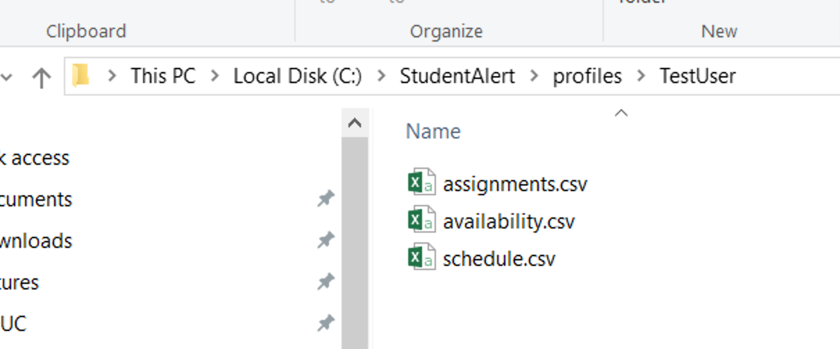

Figure 2: Data file structure

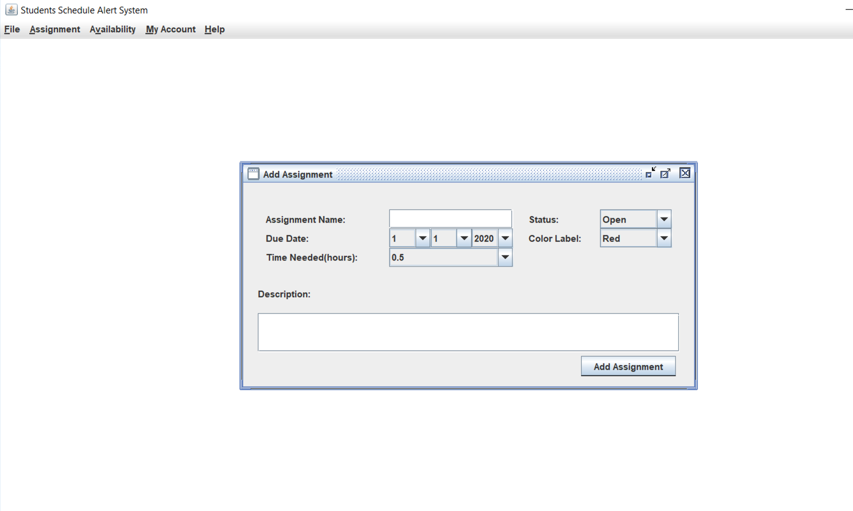

Figure 3: Add Assignment Screen

# Phase 3

## Milestones

We have completed the project plan, test case, user guide, software design specification and GUI design. The last few weeks, we had developed the GUI skeleton, added methods for each of the components, and tweaked the GUI design to fit the software needs. This week, we added input validation, ability to read and write to and from the data files, and the function to build the schedule.

## Current Status

This week, as stated above, we added input validation to the user registration screen, the availability screen, and the assignment screens. Last week we created the availability page and made it read from the file. This week, we made it write back to the file from the Jtable modifications. We also added the ability to read and write to file from the add/edit/ and delete assignment screens. The user file is now also created when a user is registered and is read every time the application starts. FInally, we’ve created the schedule file and the ability to generate the schedule using the availability and the assignments that have been added by the user.

